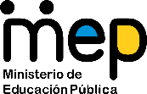
Guía de trabajo autónomo para décimo año (unidad 2)
Self-Study Guide for 10th grade (Unit 2)
El trabajo autónomo es la capacidad de realizar tareas por nosotros mismos, sin necesidad de que nuestros/as docentes estén presentes.
Centro Educativo/ School Name:
Educador/a Teacher:
Nivel/ Level: 10 th
Asignatura/ Subject: English
- Me preparo para hacer la guía/ Getting ready to do my self-study guide

Pautas que debo verificar antes de iniciar mi trabajo. /Aspects to verify before I start working:
Materiales o recursos que voy a necesitar/  Materials needed | Suggested materials:  - Notebook, pencil, pen, eraser, highlighters, etc.  - Self- study guide #2 for 10th grade  - Computer & Internet access if possible
Condiciones que debe tener el lugar donde voy a trabajar/ Conditions of the place to work | - Work in a place where you do your assignments and homework daily.
Tiempo en que se espera que realice la guía/  Expected time to work this self-study guide | - This self-study guide will take you 80 minutes to be completed.

- Voy a recordar lo aprendido en clase. Recalling what I learned in class.
Indicaciones /  Instructions | Dear student,  The following tasks will help you review and reinforce Unit 2: Stories Come in All Shapes and Sizes
Actividad / Activity  Preguntas para reflexionar y responder  Questions to reflect on and answer | Task 1. Ask yourself the following question… Have I ever experienced something in my life that I would like to tell others? What was it about? Think about it…  Task 2: Now ask the following question to some relative (brother, sister, father, mother, grandmother,etc) … Have your ever experienced something in your life that you would like to tell others? What was it about? Think about it and tell me.

- Pongo en práctica lo aprendido en clase / Putting into practice what I learned in class.
Indicaciones /  Instructions | Task 1. Read following digital section of The New York Times and answer the following question:  What is it about?  A) A girl’s story told in a diary during coronavirus quarantine.  B) A girl making drawings of her house during quarantine.  C) A girl staying home with coronavirus disease.  The Quarantine Diaries  Around the world, the history of our present moment is taking shape in journal entries and drawings.  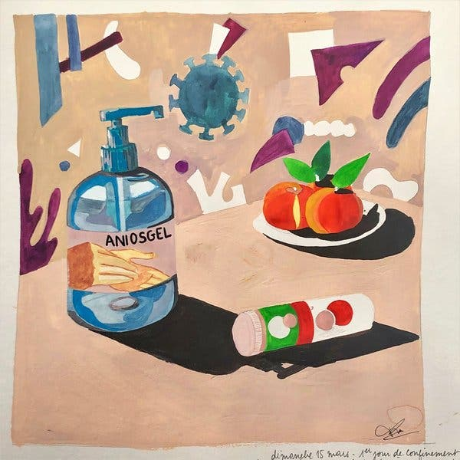  Margaux Rebourcet, a 28-year-old artist who lives in Nanterre, France, has found solace in her work. “We are now isolated,” she said.Credit...Margaux Rebourcet  By Amelia Nierenberg  March 30, 2020  Before the end of life as we knew it, Ady, an 8-year-old who lives in the Bay Area of San Francisco, read a biography of Anne Frank.  When she realized that she, too, was living through what would soon become history, Ady started keeping her own diary.  In one early entry, she recorded that the judging for her county’s science fair would be conducted over the phone, rather than in person. “Not ‘fair’!!” she wrote. “Har, har, very funny.”  When Santa Cruz County enacted a shelter-in-place order on March 16, she again picked up her pen.  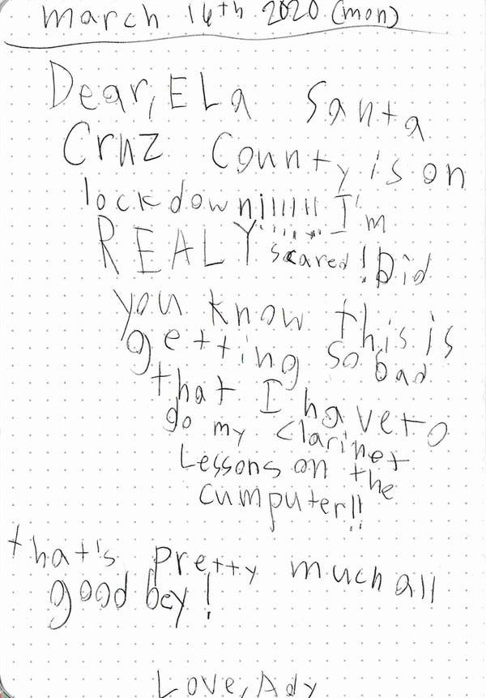  “I’m REALY scared!” she wrote. “Did you know this is getting so bad that I have to go my clarinet lessons on the cumputer!!”  Ady calls her diary Ela, as in the first syllable of the word “elephant” (one of her favorite animals). Credit...Ady  “You can say anything you want, no matter what, and nobody can judge you,” Ady said in a phone interview earlier this month, speaking about her diary. “No one says, ‘scaredy-cat.’”  As the coronavirus continues to spread and confine people largely to their homes, many are filling pages with their experiences of living through a pandemic. Their diaries are told in words and pictures: pantry inventories, window views, questions about the future, concerns about the present.Taken together, the pages tell the story of an anxious, claustrophobic world on pause.  Source: Taken from https://www.nytimes.com/2020/03/30/style/coronavirus-diaries-social-history.html  Task 2. Answer the following questions with information from the digital section of the New York Times above. You can type the answers or write them down in your notebook.  - What happened after Ady read Anne Frank´s biography?  - How is Ady feeling with the situation her county is facing due to coronavirus?  - What is the meaning of Ady´s phrase “No one says, ‘scaredy-cat”?  Task 3. Imagine that you are keeping a diary with daily entries of your days during quarantine because of coronavirus. If you had to write a personal story about what you have learned from this experience, what would you write about? Write your personal story in your notebook.
Indicaciones o preguntas para auto regularse y evaluarse/ Instructions or questions for self-regulation and self- assessment | Review the following questions to self-regulate and self-assess:  Did I read the instructions carefully?  Did I check on the words that I didn’t understand?  Did I use a dictionary or asked a relative about the meaning of the words that I didn’t understand?  Did I read the instructions again when I didn’t understand what I had to do?

Con el trabajo autónomo voy a aprender a aprender/

With the self-study guide, I’m going to learn how to learn.

Reviso las acciones realizadas durante la construcción del trabajo. /
I check the actions carried out while completing the self-study guide

Marco una X encima de cada símbolo al responder las siguientes preguntas/
Mark with an X on the icon that answers the following questions.

¿Leí las indicaciones con detenimiento?
Did I read the instructions carefully?
¿Revisé las palabras que no conocía?
Did I check on the words that I didn’t understand?
¿Busqué en el diccionario o consulté con un familiar el significado de las palabras que no conocía?
Did I use the dictionary or asked a relative about the meaning of the words that I didn’t understand?
¿Me devolví a leer las indicaciones cuando no comprendí qué hacer?
Did I read the instructions again when I didn’t understand what I had to do?

Con el trabajo autónomo voy a aprender a aprender/

With the self-study guide, I’m going to learn how to learn.

Valoro lo realizado al terminar por completo el trabajo.
I self -assess what I did when I finish the study guide.

Marca una X encima de cada símbolo al responder las siguientes preguntas
Mark with an X on the icon that answers the following questions.

¿Leí mi trabajo para saber si es comprensible lo escrito o realizado?
I proofread what I did in my self-study guide.
¿Revisé mi trabajo para asegurarme si todo lo solicitado fue realizado?
I checked my self-study guide to make sure that everything is complete.
¿Me siento satisfecho con el trabajo que realicé?
I feel satisfied with the work I did.
Explico ¿Cuál fue la parte favorita del trabajo?
What was the favorite part of this work?

¿Qué puedo mejorar, la próxima vez que realice la guía de trabajo autónomo?
What can I improve the next time I work on the self study guide?

