Guía de trabajo autónomo
Self-Study Guide for 11th Grade #2 (Part 2)
El trabajo autónomo es la capacidad de realizar tareas por nosotros mismos, sin necesidad de que nuestros/as docentes estén presentes.
Centro Educativo/ School Name:
Educador/a Teacher:
Nivel/ Level:
Asignatura/ Subject:

- Me preparo para hacer la guía
Pautas que debo verificar antes de iniciar mi trabajo. Getting ready to work on my self-study guide.
Pautas que debo verificar antes de iniciar mi trabajo. /Aspects to verify before I start working:
Materiales o recursos que voy a necesitar/  Materials needed | Suggested materials:  - Notebook, pencil, pen, eraser, highlighters, etc.  - Self- study guide #2 for 11th Grade  - Computer & Internet access if possible
Condiciones que debe tener el lugar donde voy a trabajar/ Conditions of the place to work | - Work in a place where you do your assignments and homework daily.
Tiempo en que se espera que realice la guía/  Expected time to work this self-study guide | - This self-study guide will take you 80 minutes to be completed.

2. Voy a recordar lo aprendido en clase. Recalling what I learned in class.
Indicaciones /  Instructions | Dear student,  The following tasks will help you review and reinforce Unit 2: Tourist Aspects Worldwide.
Actividad / Activity  Preguntas para reflexionar y responder  Questions to reflect on and answer | Task 1. Before reading: Ask yourself… What are some famous tourist attractions around the world? Write them down on your notebook  Ask your brother, sister, mother, grandmother or any relative at home…  - What places would they love to visit around the world?  - List the continents and write some top tourist destinations from each.
3.Pongo en práctica lo aprendido en clase / Putting into practice what I learned in class.
Indicaciones /  Instructions | Task 2. While- reading: Go over the article. https://www.worldatlas.com/articles/top-tourist-destinations-in-the-world.html. Then, answer the following question.  Top Tourist Destinations In The World  Cities such as Hong Kong, London, Paris, Dubai, and New York have earned reputations for being top tourist destinations.  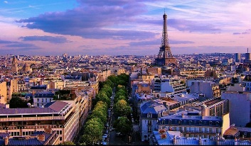  The beautiful city of Paris is one of the top tourist destinations in the world. Some cities across the world are well-known tourist destinations and manage to attract the bulk of the global tourists. These cities might offer a vibrant nightlife, an old world charm, thriving shopping centers, gastronomic delights or rich cultural experiences to the international tourists. Whatever be the reason, there is no doubt that Hong Kong, London, Singapore, Bangkok, Paris, Macau, Dubai, New York, Istanbul and Kuala Lumpur are the world's most popular tourist destinations.  10. Kuala Lumpur -  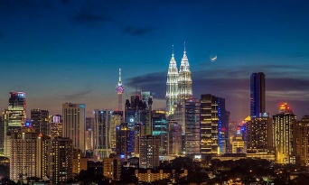  Kuala Lumpur, the Malaysian capital city is also one of the top tourist destinations in the world. The city serves as the base for tourists touring Malaysia. The city has a modern skyline that is dominated by the world’s tallest twin buildings, the Petronas Twin Towers. Kuala Lumpur is also known for its British colonial era landmarks. A number of international sports, musical, and other events are also held in this city.  Things To See And Do: The most visited tourist attractions in Malaysia include the House of Parliament, the National Museum, the National Monument, the Petaling Street, the Merdeka Square, the Jamek Mosque, Central Market, etc. Cultural festivals like the Thaipusam procession are held in this city. Kuala Lumpur is also famous for its lively nightlife, wide choice of restaurants, international hotel chains, and thriving shopping centers.  9. Istanbul -  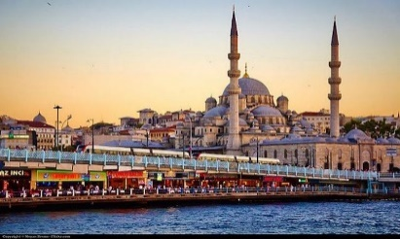  Istanbul, the historical Constantinople, is Turkey’s capital and most populous city. The city’s strategic location as a transcontinental Eurasian city has attracted a large number of empires and conquerors to this city in the past. Today, the city serves as one of the top tourist destinations in the world and is regarded as the cultural and historical center of Turkey. The old-world charm of the city, its numerous palaces, mosques, and other historical sites make it a favorite destination for many.  Things To See And Do: Aya Sofya, Topkapı Palace, Blue Mosque (Sultan Ahmet Camii), Basilica Cistern (Yerebatan Sarnıçı), Hippodrome, Istanbul Archaeology Museum, Grand Bazaar (Kapalı Çarşı), Süleymaniye Mosque, Spice Bazaar (Mısır Çarşısı), Dolmabahçe Palace, Chora Church (Kariye Müzesi), Museum of Turkish and Islamic Arts are some of major attractions of Istanbul.  8. New York -  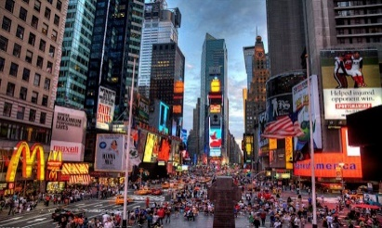  The most populous city in the US, the New York City is located at the New York state’s southern tip. The city is known across the world as a dynamic and cosmopolitan center in the country. It is associated with glitter and glamor and is a dream destination for many across the world. New York City received a record 60 million visitors in 2015 which exhibits the popularity of this city as a global tourist hotspot. US$61.3 billion worth revenue in tourism was generated in 2014 in this city.  Things To See And Do: Major tourist attractions in this city include the Statue of Liberty, Central Park, Empire State Building, Metropolitan Museum of Art, Times Square, Ellis Island, Broadway theater productions, Manhattan Chinatown and others. New York also hosts major cultural events and international festivals throughout the year. Helicopter and balloon tours, cultural and theme tours are some of the activities offered to tourists visiting the city.  7. Dubai -  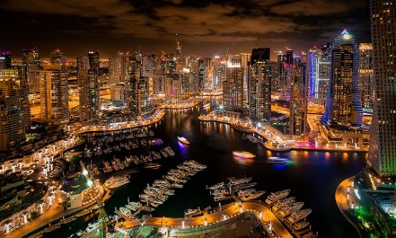  The cosmopolitan city of the United Arab Emirates, Dubai is known for its stunning highrises, ultramodern architecture, man-made islands, gold souks, sparkling malls, luxury shopping destinations, lively nightlife scenes, and more.  Things To See And Do: The Dubai government aims to develop tourism as a major source of income in the emirate. The city is dubbed as the "shopping capital of the Middle East.” The Dubai Mall, the world’s largest shopping center is located here along with 70 other such centers. The souk districts of Dubai are famous like the Gold Souk in Deira. The Dubai Creek has been proposed as a UNESCO World Heritage Site. Other tourist attractions in Dubai, one of the top tourist destinations in the world, include the Dolphinarium, Camel Rides, Cable Car, Exotic Birds Shows, etc.  6. Macau -  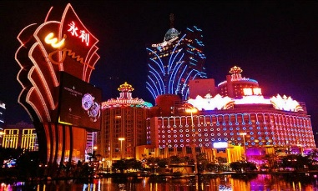  Macau is an autonomous territory on the Pearl River Delta’s western side in East Asia. Today, the region is one of the richest regions in the world. In 2006, Macau became famous as the largest gambling center in the world. Tourism and gambling are the two important sources of income in Macau. Festivals like the Chinese New Year, Spring Lantern Festival, Ching Ming Festival, Birthday of the Buddha are some of the interesting and exciting festivals hosted in Hong Kong. The region also offers well-maintained public swimming pools and excellent beaches. Sailing, hiking, camping, and also gambling are some of the activities enjoyed here by tourists of varying tastes.  Things To See And Do: Macau has an electrifying atmosphere and is rich in attractions due to the interesting fusion of Chinese and European cultures in this region of the world. Macau has numerous temples, churches, and fortresses. The narrow alleyways in the old parts of Macau serve to attract the curious tourist who is in the mood for exploration. There is also the opportunity to head to the islands of Macau or relax in the pretty gardens there. The Bodhisatta Avalokitesvara, Macau Tower, Fisherman's Wharf, Macau Museum, Museum of Taipa and Coloane History, etc., are some of the other attractions in Macau that attend to the needs of all types of tourists. Casinos of the city also offer tourists the unique opportunity to enjoy testing their fortunes in a gambling games.  5. Paris -  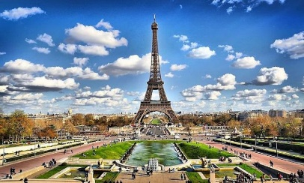  Paris is the biggest and capital city of France that is located in the River Seine’s north-bending arc in northern central France. Like London, Paris has a rich culture and history that makes it one of the most coveted tourist destinations in the world. It is labeled as a romantic city and newlyweds often dream to spend their honeymoon in Paris. Lovers of fine arts, music, and fashion also flock to this city in large numbers.  Things To See And Do: The Notre Dame Castle, the Louvre Museum, Basilique du Sacré-Cœur, Eiffel Tower, Centre Pompidou, Les Invalides, Musée d'Orsay, Disneyland Paris, Marne-la-Vallée are some of the major attractions of Paris. The banks of the Seine in Paris have been listed as a UNESCO World Heritage Site since 1991.  4. Bangkok -  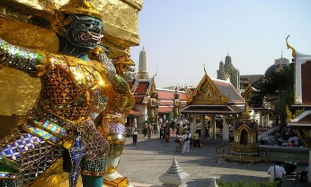  Bangkok is Thailand’s largest and capital city which is located in the Chao Phraya River delta in the country. It is one of the top tourist destinations in the world. Bangkok serves as the main gateway for international tourists entering Thailand. The multi-faceted attractions, happening urban life, and rich culture of the city makes it a favorite among tourists seeking entertainment at a reasonable price. The dynamic nightlife of Bangkok attracts young tourists from across the world. Sex tourism, though not openly acknowledged by the government of Thailand, is believed to be largely prevalent in the city.  Things To See And Do: The Grand Palace; Buddhist temples like Wat Phra Kaew, Wat Arun; Vimanmek Mansion (regarded as the world's largest teak building); Bangkok National Museum; Royal Barge National Museum; cruises on the Chao Phraya River, shopping, and nightlife.  3. Singapore -  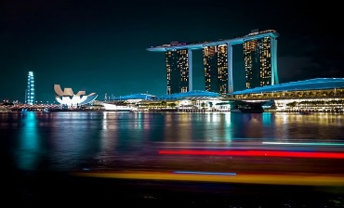  Singapore is the world's only island city-state, located off the coast of Malaysia in Southeast Asia. Singapore is famous for its multicultural population and tropical climate. It is also a global financial center. Tourism is a major industry in Singapore and contributes significantly to the country’s economy. In 2015, 15,231,469 international tourists visited Singapore, a figure that is three times the size of Singapore’s population.  Things To See And Do: Singapore Zoo, Jurong Bird Park, Night Safari, River Safari, Singapore Botanic Gardens, and Gardens by the Bay are popular natural attractions in Singapore. The Singapore Botanic Gardens have been inscribed as a UNESCO World Heritage Site. Among the cultural and historical landmarks of Singapore are the Masjid Sultan, Sri Mariamman Temple, Kranji War Memorial, Victoria Theatre and Concert Hall, Civilian War Memorial, National Museum of Singapore, Istana Kampong Glam, and others. Singapore is also a popular shopping destination and has several shopping belts populated by avid shoppers.  2. London -  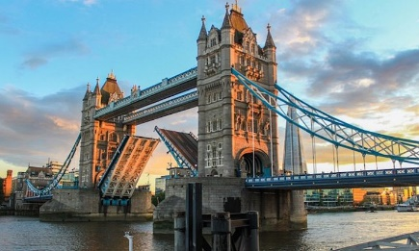  London, the biggest and capital city of the United Kingdom, is located on the banks of the Thames River in the southeastern section of the Great Britain island. London has a rich history and culture that makes it one of the most visited cities in the world. London’s art galleries exhibit spectacular paintings by famous painters, the city’s museums have rich collections of historic and prehistoric artifacts, and buildings display a great diversity of architectural styles from the past to the present. The Tower of London in the city also hosts the Crown Jewels, a rare collection of jewels including the Kohinoor diamond owned by the royal house of the country.  Things To See And Do: The British Museum, Tate Modern, Tower of London, National Portrait Gallery, Southbank Centre, Natural History Museum, National Gallery, Victoria and Albert Museum, etc., are some of the most visited tourist spots in London. Operas at the Royal Opera House, Change of Guards at the Buckingham Palace, horror tour of London at the London Dungeon, a walk by the Thames, etc., are some of the tourist activities to be enjoyed in London.  1. Hong Kong -  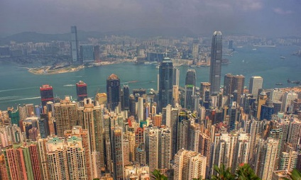  Hong Kong is an autonomous territory located in East Asia’s Pear River Delta. Hong Kong is regarded as a tourist magnet as it manages to attract millions of tourists from all corners of the globe. What makes Hong Kong so lucrative to international visitors?  Things To See And Do: Almost all the districts of Hong Kong offers a large number of attractions and activities to the tourists. The Victoria Peak, Ocean Park Hong Kong, Sleeping Beauty Castle, Lantau Island, Po Lin Monastery, Hong Kong Museum of History, Man Mo Temple are some of the many attractions of the place. Hong Kong is also a shopper's mecca and hosts both luxury malls and streetside markets where one can buy clothing, accessories, electronic goods, jade, antiques, etc. Ferry and junk boat rides can be enjoyed by tourists visiting the city. Remarkable hiking options are also offered to visitors. Food lovers also find a wide variety of cuisine choices in the innumerable number of restaurants and eateries in Hong Kong.  Source: Taken from https://www.worldatlas.com/articles/top-tourist-destinations-in-the-world.html  Task 3. What’s the article about?  ------------------------------------------------------------------------------------------------------------------------------------------------------------------------------------------------------------------------------------------------------------------------------------------------------------------------------------------------------------------------------  Task 4. Fill in the following chart. Use the information form the article.  Place Places’ characteristics Things to do Things to see  Kuala Lumpur  Istanbul  New York  Dubai  Macau  Paris  Bangkok  Singapore  London  Hong Kong  Task 3. After- reading. Surf this site and expand your knowledge about Tourist Aspects Worldwide. Check Unit 2 11th grade. Review vocabulary practices and play the game. https://recursos.mep.go.cr/cyberlab_10_11/
Indicaciones o preguntas para auto regularse y evaluarse/ Instructions or questions for self-regulation and self- assessment | Review the following questions to self-regulate and self-assess:  ¿Leí las indicaciones con detenimiento?  Did I read the instructions carefully?  ¿Subrayé las palabras que no conocía?  Did I underline the words that I didn’t understand?  ¿Busqué en el diccionario o consulté con un familiar el significado de las palabras que no conocía?  Did I use the dictionary or asked a relative about the meaning of the words that I didn’t understand?  ¿Me devolví a leer las indicaciones cuando no comprendí qué hacer?  Did I read the instructions again when I didn’t understand what I had to do?

Con el trabajo autónomo voy a aprender a aprender/

With the self-study guide, I’m going to learn how to learn.

Reviso las acciones realizadas durante la construcción del trabajo. /
I check the actions carried out while completing the self-study guide

Marco una X encima de cada símbolo al responder las siguientes preguntas/
Mark with an X on the icon that answers the following questions.

¿Leí las indicaciones con detenimiento?
Did I read the instructions carefully?
¿Subrayé las palabras que no conocía?
Did I underline the words that I didn’t understand?
¿Busqué en el diccionario o consulté con un familiar el significado de las palabras que no conocía?
Did I use the dictionary or asked a relative about the meaning of the words that I didn’t understand?
¿Me devolví a leer las indicaciones cuando no comprendí qué hacer?
Did I read the instructions again when I didn’t understand what I had to do?

Con el trabajo autónomo voy a aprender a aprender/

With the self-study guide, I’m going to learn how to learn.

Valoro lo realizado al terminar por completo el trabajo.
I self -assess what I did when I finish the study guide.

Marca una X encima de cada símbolo al responder las siguientes preguntas
Mark with an X on the icon that answers the following questions.

¿Leí mi trabajo para saber si es comprensible lo escrito o realizado?
I proofread what I did in my self-study guide.
¿Revisé mi trabajo para asegurarme si todo lo solicitado fue realizado?
I checked my self-study guide to make sure that everything is complete.
¿Me siento satisfecho con el trabajo que realicé?
I feel satisfied with the work I did.
Explico ¿Cuál fue la parte favorita del trabajo?
What was the favorite part of this work?

¿Qué puedo mejorar, la próxima vez que realice la guía de trabajo autónomo?
What can I improve the next time I work on the self study guide?

Remember: Stay home. Let’s flatten the curve.

