Guía de trabajo autónomo
Self-Study Guide for 7th Grade (Unit 1)
El trabajo autónomo es la capacidad de realizar tareas por nosotros mismos, sin necesidad de que nuestros/as docentes estén presentes.
Centro Educativo/ School Name:
Educador/a Teacher:
Nivel/ Level:
Asignatura/ Subject:
- Me preparo para hacer la guía/ Getting ready to do my self-study guide

Pautas que debo verificar antes de iniciar mi trabajo./Aspects to verify before I start working:
Materiales o recursos que voy a necesitar/  Materials needed | Suggested materials:  - Notebook, pencil, pen, eraser, highlighters, etc.  - Self- study guide #1 for 7th Grade  - Computer & Internet access if possible
Condiciones que debe tener el lugar donde voy a trabajar/ Conditions of the place to work | - Work in a place where you do your assignments and homework daily.
Tiempo en que se espera que realice la guía/  Expected time to work this self-study guide | - This self-study guide will take you 80 minutes to be completed.

- Voy a recordar lo aprendido en clase. Recalling what I learned in class.
Indicaciones /  Instructions | Dear student,  The following tasks will help you to reinforce information about yourself and your family related to the scenario Here I Am!.
Task 1. Find one person from your family and ask the following questions. Then, complete the graphic organizer.

- What’s your name?
- How old are you?
- What do you like to do?
- What’s your telephone number?
- What are you like?
Actividad / Activity

Preguntas para reflexionar y responder

Questions to reflect on and answer
- Pongo en práctica lo aprendido en clase / Putting into practice what I learned in class.
Indicaciones /  Instructions | Task 2 Complete the following sentences to introduce yourself.  - Hello. My name is___________________________.  - I am _______________ years old.  - I live in ____________________________________.  - I go to__________________________ school.  - My parents are ___________________________.  - My favorite food is ______________________.  I like ____________________________________. 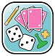  Source for art: www.clipart-library.com  Task 3 Watch Profe en Casa video: http://www.mep.go.cr/educatico/family-members and fill in the following chart. If you have no internet access describe the members of your family.  - List 5 family members mentioned in the video.  - Write one sentence description for each member by using the information provided in the video or your family information.  Family members mentioned in the video Description  Sister She lives in USA.  Task 3 Fill in the blanks with your information.  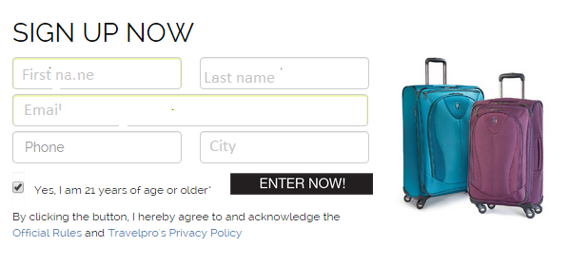  Task 4 Complete the following sentences about your family members using and/but/because and.  See examples:  My sister is great because she speaks three languages.  My brother loves soccer but hates tennis.  My Mom is beautiful and happy.  - My __(family member)__ is _____ because ___.  - My __(family member)__ is _____ but _____.  - My __(family member)__ is _____ and _____,  Task 5 Use the activities from Cyberlab to practice more. http://cyberlab.ucr.ac.cr/cyberlab/booklets_students/booklet_8th/unit1_8th_booklet.pdf
Indicaciones o preguntas para auto regularse y evaluarse/ Instructions or questions for self-regulation and self- assessment | Review the following questions to self-regulate and self-assess:  ¿Leí las indicaciones con detenimiento?  Did I read the instructions carefully?  ¿Subrayé las palabras que no conocía?  Did I underline the words that I didn’t understand?  ¿Busqué en el diccionario o consulté con un familiar el significado de las palabras que no conocía?  Did I use the dictionary or asked a relative about the meaning of the words that I didn’t understand?  ¿Me devolví a leer las indicaciones cuando no comprendí qué hacer?  Did I read the instructions again when I didn’t understand what I had to do?

Con el trabajo autónomo voy a aprender a aprender/

With the self-study guide, I’m going to learn how to learn.

Reviso las acciones realizadas durante la construcción del trabajo. /
I check the actions carried out while completing the self-study guide

Marco una X encima de cada símbolo al responder las siguientes preguntas/
Mark with an X on the icon that answers the following questions.

¿Leí las indicaciones con detenimiento?
Did I read the instructions carefully?
¿Subrayé las palabras que no conocía?
Did I underline the words that I didn’t understand?
¿Busqué en el diccionario o consulté con un familiar el significado de las palabras que no conocía?
Did I use the dictionary or asked a relative about the meaning of the words that I didn’t understand?
¿Me devolví a leer las indicaciones cuando no comprendí qué hacer?
Did I read the instructions again when I didn’t understand what I had to do?

Con el trabajo autónomo voy a aprender a aprender/

With the self-study guide, I’m going to learn how to learn.

Valoro lo realizado al terminar por completo el trabajo.
I self -assess what I did when I finish the study guide.

Marca una X encima de cada símbolo al responder las siguientes preguntas
Mark with an X on the icon that answers the following questions.

¿Leí mi trabajo para saber si es comprensible lo escrito o realizado?
I proofread what I did in my self-study guide.
¿Revisé mi trabajo para asegurarme si todo lo solicitado fue realizado?
I checked my self-study guide to make sure that everything is complete.
¿Me siento satisfecho con el trabajo que realicé?
I feel satisfied with the work I did.
Explico ¿Cuál fue la parte favorita del trabajo?
What was the favorite part of this work?

¿Qué puedo mejorar, la próxima vez que realice la guía de trabajo autónomo?
What can I improve the next time I work on the self study guide?

