Guía de trabajo autónomo
Self-Study Guide for 8th Grade (Unit 1)
El trabajo autónomo es la capacidad de realizar tareas por nosotros mismos, sin necesidad de que nuestros/as docentes estén presentes.
Centro Educativo/ School Name:
Educador/a Teacher:
Nivel/ Level:
Asignatura/ Subject:
- Me preparo para hacer la guía/ Getting ready to do my self-study guide

Pautas que debo verificar antes de iniciar mi trabajo. /Aspects to verify before I start working:
Materiales o recursos que voy a necesitar/  Materials needed | Suggested materials:  - Notebook, pencil, pen, eraser, highlighters, etc.  - Self- study guide #1 for 8th Grade  - Computer & Internet access if possible  - If not internet access, see the transcript at the end of this study-guide to complete task 4.
Condiciones que debe tener el lugar donde voy a trabajar/ Conditions of the place to work | - Work in a place where you do your assignments and homework daily.
Tiempo en que se espera que realice la guía/  Expected time to work this self-study guide | - This self-study guide will take you 80 minutes to be completed.

- Voy a recordar lo aprendido en clase. Recalling what I learned in class.
Indicaciones /  Instructions | Dear student,  The following tasks will help you to reinforce information about the scenario “My High School… Our place”. They include your school’s activities, schedules and subjects. You will have an opportunity to work on your pronunciation, as well.
Actividad / Activity  Preguntas para reflexionar y responder  Questions to reflect on and answer | Task 1. Answer the following questions about your schedule.  - What classes do you attend on Friday?  ____________________________________________________________________  - Where is your Science class?  ____________________________________________________________________  - When do you attend French?  ____________________________________________________________________  - Where is your Social Studies class?  ____________________________________________________________________  - What classes do you attend on Monday?  ____________________________________________________________________  - What is your least favorite class?  ____________________________________________________________________  - What’s your favorite class?  ____________________________________________________________________
- Pongo en práctica lo aprendido en clase / Putting into practice what I learned in class.
Indicaciones /  Instructions | Task 2. Read the schedule and answer the following questions  Time Monday Tuesday Wednesday Thursday Friday  8:00am-9:15am Biology P.E. Art Chemistry Spanish  9:30am-10:45am Biology Chemistry Math Compter Science P.E  11:00am-11:50am English Free Math Spanish Free  12:00pm-12:45pm Lunch Lunch Lunch Lunch Lunch  1:00pm-2:20pm Geography English Music Geography Music  2:30pm-3:10pm Geography Spanish Spanish English Free  3:20pm-4:00pm Art Computer Science Free English Free  - What classes do students attend on Tuesday?  - What class do students attend on Friday after lunch?  - On Wednesday, what time do students cut class?  - How often do students have Geography lessons?  - When do students have a full schedule?  Task 3. Read the chart about Ben’ school activities.  Ben school activities Always ⁒100 Usually ⁒90 Often ⁒70 Seldom ⁒10 Never ⁒0  Band practice  Go to the Wood Shop  Participate in School Assemblies  Dances  Go to field Trips  Participate in the Choir  Talk to teachers  Talk to my parents while I’m at school  Spend time with my classmates  Talk to the librarian  Visit the principal’s office  Help the janitor to pick up my own garbage  Greet the security guard when I arrive to school  - Write a sentence for each activity to describe what Ben does  For example: Ben never attends the band practice.  ---------------------------------------------------------------------------------------------------------------------------------------------------------------------------------------------------------------------------------------------------------------------------------------------------------------------------------------------------------------------------------------------------------------------------------------------------------------------------------------------------------------------------------------------------------------------------------------------------------------------------------------------------------------------------------------------------------------------------------------------------------------------------------------------------------------------------------------------------------------------------------------------------------------------------------------------------------------------------------------------------------------------------------------------------------------------------------------------------------------  - Check your sentences using the following chart.  My sentences…  begin with capital letter. Yes No  have a period at the end. Yes No  don’t have spelling problems. Yes No  have a subject that matches the verb correctly. Yes No  Task 4. Watch the video: https://www.youtube.com/watch?v=ySnnuIiiHII  - List long vowel and short vowel examples from the video on the correct box.  Long vowel sound words Short vowel sound words  - Practice the sentences from the video by repeating them.  - Write 5 sentences using one long vowel word and one short vowel word on each.  Source: americanenglish.state.org
Indicaciones o preguntas para auto regularse y evaluarse/ Instructions or questions for self-regulation and self- assessment | Review the following questions to self-regulate and self-assess:  ¿Leí las indicaciones con detenimiento?  Did I read the instructions carefully?  ¿Subrayé las palabras que no conocía?  Did I underline the words that I didn’t understand?  ¿Busqué en el diccionario o consulté con un familiar el significado de las palabras que no conocía?  Did I use the dictionary or asked a relative about the meaning of the words that I didn’t understand?  ¿Me devolví a leer las indicaciones cuando no comprendí qué hacer?  Did I read the instructions again when I didn’t understand what I had to do?

Con el trabajo autónomo voy a aprender a aprender/

With the self-study guide, I’m going to learn how to learn.

Reviso las acciones realizadas durante la construcción del trabajo. /
I check the actions carried out while completing the self-study guide

Marco una X encima de cada símbolo al responder las siguientes preguntas/
Mark with an X on the icon that answers the following questions.

¿Leí las indicaciones con detenimiento?
Did I read the instructions carefully?
¿Subrayé las palabras que no conocía?
Did I underline the words that I didn’t understand?
¿Busqué en el diccionario o consulté con un familiar el significado de las palabras que no conocía?
Did I use the dictionary or asked a relative about the meaning of the words that I didn’t understand?
¿Me devolví a leer las indicaciones cuando no comprendí qué hacer?
Did I read the instructions again when I didn’t understand what I had to do?

Con el trabajo autónomo voy a aprender a aprender/

With the self-study guide, I’m going to learn how to learn.

Valoro lo realizado al terminar por completo el trabajo.
I self -assess what I did when I finish the study guide.

Marca una X encima de cada símbolo al responder las siguientes preguntas
Mark with an X on the icon that answers the following questions.

¿Leí mi trabajo para saber si es comprensible lo escrito o realizado?
I proofread what I did in my self-study guide.
¿Revisé mi trabajo para asegurarme si todo lo solicitado fue realizado?
I checked my self-study guide to make sure that everything is complete.
¿Me siento satisfecho con el trabajo que realicé?
I feel satisfied with the work I did.
Explico ¿Cuál fue la parte favorita del trabajo?
What was the favorite part of this work?

¿Qué puedo mejorar, la próxima vez que realice la guía de trabajo autónomo?
What can I improve the next time I work on the self study guide?

Task 4. Story transcript If not internet access to complete task 4.
a. Read the story below to one of your family members.

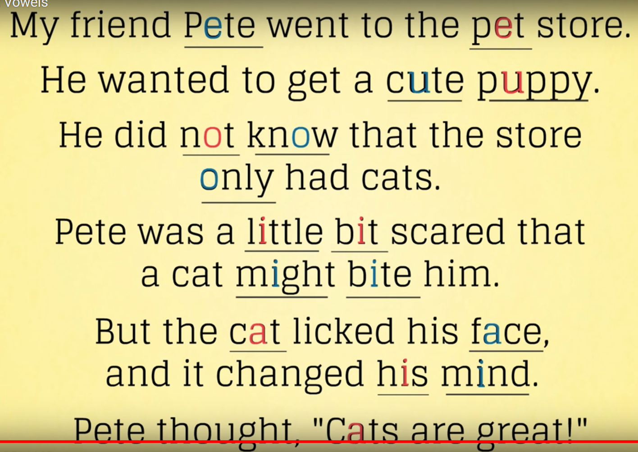

b. List long vowel and short vowel examples from the story on the correct box after reading them out loud.
Long vowel sound words | Short vowel sound words

Write 5 sentences using one long vowel word and one short vowel word on each.

