Guía de trabajo autónomo número 2 para noveno año (Unidad 2)-
Self-Study Guide # 2 for 9th grade (Unit 2)
El trabajo autónomo es la capacidad de realizar tareas por nosotros mismos, sin necesidad de que nuestros/as docentes estén presentes.
Centro Educativo/ School Name:
Educador/a Teacher:
Nivel/ Level: 9th
Asignatura/ Subject: English
- Me preparo para hacer la guía/ Getting ready to do my self-study guide

Pautas que debo verificar antes de iniciar mi trabajo. /Aspects to verify before I start working:
Materiales o recursos que voy a necesitar/  Materials needed | Suggested materials:  - Notebook, pencil, pen, eraser, highlighters, etc.  - Self- study guide #2 for 9th grade  - Computer & Internet access if possible
Condiciones que debe tener el lugar donde voy a trabajar/ Conditions of the place to work | - Work in a place where you do your assignments and homework daily.
Tiempo en que se espera que realice la guía/  Expected time to work this self-study guide | - This self-study guide will take you 80 minutes to be completed.

- Voy a recordar lo aprendido en clase. Recalling what I learned in class.
Indicaciones /  Instructions | Dear student,  The following tasks will help you review and reinforce Unit 2: Online and Connected
Actividad / Activity  Preguntas para reflexionar y responder  Questions to reflect on and answer | Task 1. Ask your parents or some relatives at home to complete the chart below… Do you know what an App is? Can you identify any of the following:  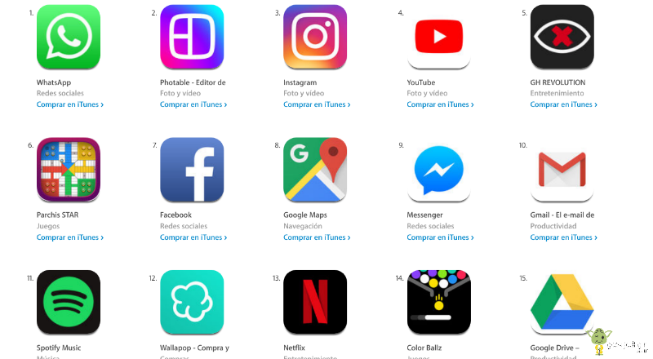  Image taken from https://blogs.imf-formacion.com/blog/tecnologia/app-store-cuales-las-app-gratuitas-mas-populares-201711/

- Pongo en práctica lo aprendido en clase / Putting into practice what I learned in class.
Indicaciones /  Instructions | Task 2. Listen to Charlie and his mother talking.  Click on the link below to listen https://learnenglishteens.britishcouncil.org/skills/listening/beginner-a1-listening/online-safety-conversation  What are they talking about? Choose and answer  A)Safety at home  B)Safety online  C)Social media  Task 3 Listen to Charlie and his mother talking again. Then check on the following sentences to decide if they are True or False  1.Charlie’s mother is doing something with his computer.  True/ False  2. Charlie isn’t logged in at the moment.  True/False  3. If you don't change your privacy settings, everyone can see your information.  True/ False  4. It is easy to delete everything you put online.  True/False  5. Charlie’s mother knows his password.  True/False  6. Charlie’s notebook is in a secret place.  True/ False  Taken from https://learnenglishteens.britishcouncil.org/skills/listening/beginner-a1-listening/online-safety-conversation  Task 4:  You are asked to write an opinion for a digital school newspaper for the civic education class. You know how students like using social media at your school. Write an email with five tips to stay safe on social media. Use the template below to write your email.  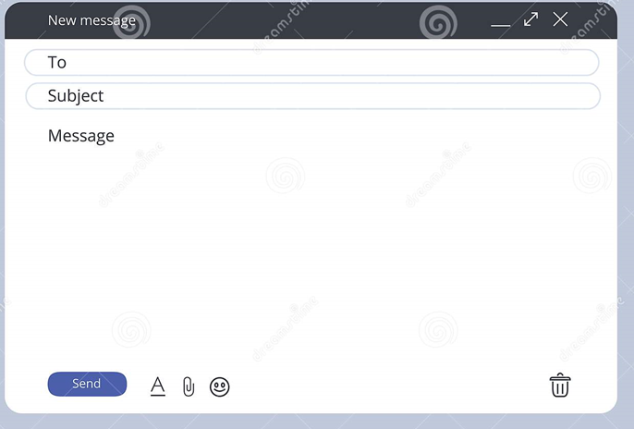
Indicaciones o preguntas para auto regularse y evaluarse/ Instructions or questions for self-regulation and self- assessment | Review the following questions to self-regulate and self-assess:  Did I read the instructions carefully?  Did I check on the words that I didn’t understand?  Did I use a dictionary or asked a relative about the meaning of the words that I didn’t understand?  Did I read the instructions again when I didn’t understand what I had to do?

Note: Transcript for tasks 2 and 3, if no Internet connection
Charlie: Mum! That's my computer!
Mum: I know, I know. Don't worry, I'm changing your privacy settings.
Charlie: Privacy settings?
Mum: Yes. There are privacy settings on your social networking sites. Your account is totally public at the moment, and you're logged in!
Charlie: Oh. What are the privacy settings for?
Mum: To make you safe online. You want to be safe, don't you? And for the right people to see your information, not EVERYONE.
Charlie: Everyone?
Mum: Yes. If you don't change your privacy settings, when you upload a photo, anyone can see it. It's important to change them so only your friends can see them. You don't want everyone to see everything, do you?
Charlie: No! But I can delete things, can't I?
Mum: Well, you can, but it's very difficult. Some things stay there forever.
Charlie: That's really scary, Mum.
Mum: Don't worry, but you must learn how to stay safe. You mustn't tell anyone your password!
Charlie: I won't!
Mum: Crazy Charlie one two one, isn't it?
Charlie: Mum! Yes, it is. How …
Mum: It's on your notebook. Right there. On your desk. It isn't a very secret place, is it?
Charlie: No, it isn't.

Con el trabajo autónomo voy a aprender a aprender/

With the self-study guide, I’m going to learn how to learn.

Reviso las acciones realizadas durante la construcción del trabajo. /
I check the actions carried out while completing the self-study guide

Marco una X encima de cada símbolo al responder las siguientes preguntas/
Mark with an X on the icon that answers the following questions.

¿Leí las indicaciones con detenimiento?
Did I read the instructions carefully?
¿Subrayé las palabras que no conocía?
Did I check on the words that I didn’t understand?
¿Busqué en el diccionario o consulté con un familiar el significado de las palabras que no conocía?
Did I use the dictionary or asked a relative about the meaning of the words that I didn’t understand?
¿Me devolví a leer las indicaciones cuando no comprendí qué hacer?
Did I read the instructions again when I didn’t understand what I had to do?

Con el trabajo autónomo voy a aprender a aprender/

With the self-study guide, I’m going to learn how to learn.

Valoro lo realizado al terminar por completo el trabajo.
I self -assess what I did when I finish the study guide.

Marca una X encima de cada símbolo al responder las siguientes preguntas
Mark with an X on the icon that answers the following questions.

¿Leí mi trabajo para saber si es comprensible lo escrito o realizado?
I proofread what I did in my self-study guide.
¿Revisé mi trabajo para asegurarme si todo lo solicitado fue realizado?
I checked my self-study guide to make sure that everything is complete.
¿Me siento satisfecho con el trabajo que realicé?
I feel satisfied with the work I did.
Explico ¿Cuál fue la parte favorita del trabajo?
What was the favorite part of this work?

¿Qué puedo mejorar, la próxima vez que realice la guía de trabajo autónomo?
What can I improve the next time I work on the self study guide?

