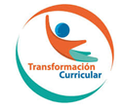
Guía de trabajo autónomo para undécimo año (unidad 2 )- Parte 1
Self-Study Guide for 11th grade (Unit 2) – Part 1
El trabajo autónomo es la capacidad de realizar tareas por nosotros mismos, sin necesidad de que nuestros/as docentes estén presentes.
Centro Educativo/ School Name:
Educador/a Teacher:
Nivel/ Level: 11th
Asignatura/ Subject: English
- Me preparo para hacer la guía/ Getting ready to do my self-study guide

Pautas que debo verificar antes de iniciar mi trabajo. /Aspects to verify before I start working:
Materiales o recursos que voy a necesitar/  Materials needed | Suggested materials:  - Notebook, pencil, pen, eraser, highlighters, etc.  - Self- study guide # 2 for 11th grade  - Computer & Internet access if possible
Condiciones que debe tener el lugar donde voy a trabajar/ Conditions of the place to work | - Work in a place where you do your assignments and homework daily.
Tiempo en que se espera que realice la guía/  Expected time to work this self-study guide | - This self-study guide will take you 80 minutes to be completed.

- Voy a recordar lo aprendido en clase. Recalling what I learned in class.
Indicaciones /  Instructions | Dear student,  The following tasks will help you review and reinforce Unit 2: Tourist aspects worldwide
Actividad / Activity  Preguntas para reflexionar y responder  Questions to reflect on and answer | Before reading: Ask yourself… What countries would you like to visit? What activities would you like to do there? Write them down on your notebook  Ask your parents or any relative (bother, sister, aunt, etc) at home… Have you ever visited a foreign country? Tell me about it.

- Pongo en práctica lo aprendido en clase / Putting into practice what I learned in class.
Indicaciones /  Instructions | While- reading :  - Look at each picture. Then read each description and match it with a picture of a tourist attraction. Use numbers from 1 to 13.  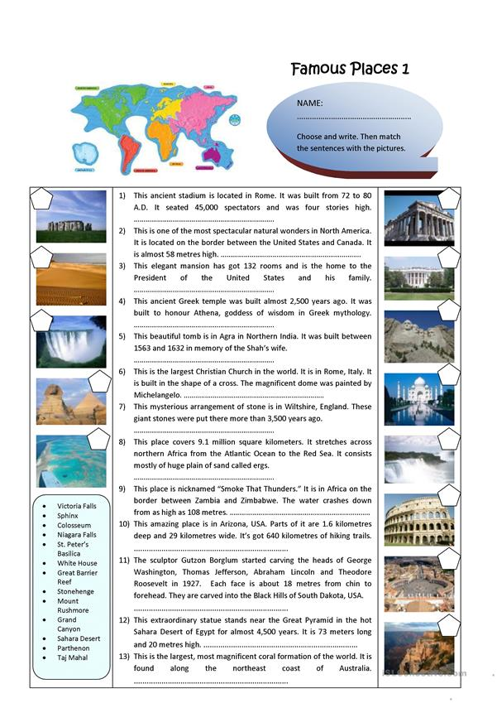  Taken from https://en.islcollective.com/english-esl worksheets/vocabulary/places/famous-places/2138  - Read the text below about Chichen Itza.  10 Interesting Facts About Chichen Itza  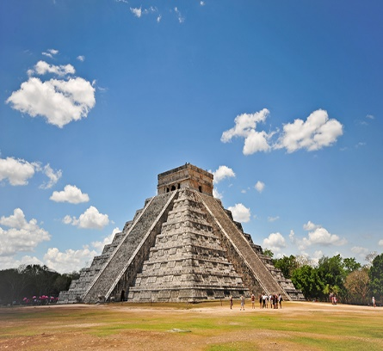  Posted on May 3, 2017 by OTG Team  Chichen Itza is an archaeological site in Yucatan and one of the most visited locations in Mexico. Rich in history and the centre of pilgrimage for the ancient Maya civilization for over 1,000 years, Chichen Itza is full of interesting facts. Read on to find out more about this intriguing place.  1. Chichen Itza is classified as one of the New Seven Wonders of the World and in 1988 was enlisted as an UNESCO World Heritage Site.  2. The term Chichen Itza means ‘the mouth at the well of Itza’. It is believed Itza means ‘water magicians’, deriving from the Mayan Itz for ‘magic’ and á for ‘water’.  3. El Castillo (the Temple of Kukulkan) is the famous pyramid which dominates the site of Chichen Itza and it actually sits on another much older temple.  4. Believed by archaeologists to have been a powerful economic city around 600 AD, the fall of Chichen Itza is thought to have been approximately 1000 AD.  5. The design and layout of Chichen Itza was clearly well- planned and builders constructed temples and pyramids in sets of clusters.  6. The four most well known clusters are the Great North Platform, the Ossario Group, the Central Group and the Old Chichen, which is not open to the public. The Great North Platform is home to the most visited sites of Chichen Itza, including the Kukulkan Pyramid, the Great Ball Court and the Temple of the Jaguars.  7. During the Spring (20th of March) and Autumn Equinox (22nd September), sunrays creates a shadow across the Kukulkan Pyramid that gives the appearance of a serpent slithering down the staircase.  8. Located on the north side of the Kukulkan Pyramid is a platform dedicated to the planet Venus. The Mayans were devoted astronomers and the movements of Venus held special meaning to them, with it influencing the architecture of the ancient Mayan city Uxmal.  9. Although the Kukulkan Pyramid is the most famous and most visited, there are numerous others in Chichen Itza. The Osario is very similar but smaller in size and at the centre is an opening to a natural cave  10. Many of the sites in Chichen Itza are known for their unusual sounds. If you clap once from one end of the Ball Court, it produces nine echoes in the middle of the court. Additionally, a clap in front of the Kukulkan Pyramid creates an echo resembling the serpent’s chirp.  Taken from: https://www.onthegotours.com/blog/2017/05/10-interesting-facts-about-chichen-itza/  Then answer the following questions:  - Where is Chichen Itza located?  - What is the meaning of the term Chichen Itza?  - What are some places you can visit once you get to Chichen Itza?  - What happens in this place on March 20th and September 22nd every year?  - What is unusual about this place?  After- reading  Imagine you are participating in an exchange program to a foreign country. You want to tell your best friend about some new places you have visited. Write an email or text him /her with information related to the places you`ve been to. Include a greeting, name of the places, location and activities you can do there. If you don’t have connectivity, you can use the template below to write an email.  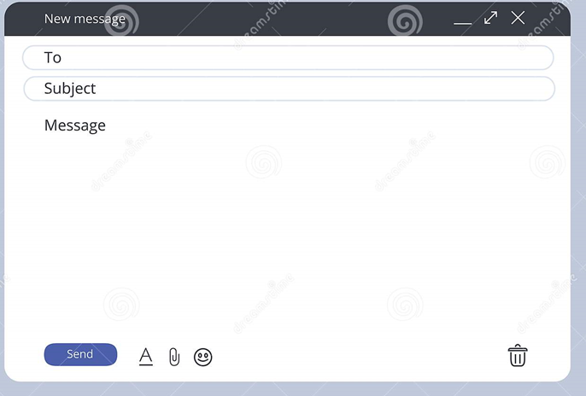
Indicaciones o preguntas para auto regularse y evaluarse/ Instructions or questions for self-regulation and self- assessment | Review the following questions to self-regulate and self-assess:  Did I read the instructions carefully?  Did I underline the words that I didn’t understand?  Did I use a dictionary or asked a relative about the meaning of the words that I didn’t understand?  Did I read the instructions again when I didn’t understand what I had to do?

Con el trabajo autónomo voy a aprender a aprender/

With the self-study guide, I’m going to learn how to learn.

Reviso las acciones realizadas durante la construcción del trabajo. /
I check the actions carried out while completing the self-study guide

Marco una X encima de cada símbolo al responder las siguientes preguntas/
Mark with an X on the icon that answers the following questions.

¿Leí las indicaciones con detenimiento?
Did I read the instructions carefully?
¿Subrayé las palabras que no conocía?
Did I underline the words that I didn’t understand?
¿Busqué en el diccionario o consulté con un familiar el significado de las palabras que no conocía?
Did I use the dictionary or asked a relative about the meaning of the words that I didn’t understand?
¿Me devolví a leer las indicaciones cuando no comprendí qué hacer?
Did I read the instructions again when I didn’t understand what I had to do?

Con el trabajo autónomo voy a aprender a aprender/

With the self-study guide, I’m going to learn how to learn.

Valoro lo realizado al terminar por completo el trabajo.
I self -assess what I did when I finish the study guide.

Marca una X encima de cada símbolo al responder las siguientes preguntas
Mark with an X on the icon that answers the following questions.

¿Leí mi trabajo para saber si es comprensible lo escrito o realizado?
I proofread what I did in my self-study guide.
¿Revisé mi trabajo para asegurarme si todo lo solicitado fue realizado?
I checked my self-study guide to make sure that everything is complete.
¿Me siento satisfecho con el trabajo que realicé?
I feel satisfied with the work I did.
Explico ¿Cuál fue la parte favorita del trabajo?
What was the favorite part of this work?

¿Qué puedo mejorar, la próxima vez que realice la guía de trabajo autónomo?
What can I improve the next time I work on the self study guide?

