Guía de trabajo autónomo para décimo año (unidad 1)
Self-Study Guide for 10th grade (Unit 1)
El trabajo autónomo es la capacidad de realizar tareas por nosotros mismos, sin necesidad de que nuestros/as docentes estén presentes.
Centro Educativo/ School Name:
Educador/a Teacher:
Nivel/ Level: 10th
Asignatura/ Subject: English
- Me preparo para hacer la guía/ Getting ready to do my self-study guide

Pautas que debo verificar antes de iniciar mi trabajo. /Aspects to verify before I start working:
Materiales o recursos que voy a necesitar/  Materials needed | Suggested materials:  - Notebook, pencil, pen, eraser, highlighters, etc.  - Self- study guide #1 for 10th grade  - Computer & Internet access if possible
Condiciones que debe tener el lugar donde voy a trabajar/ Conditions of the place to work | - Work in a place where you do your assignments and homework daily.
Tiempo en que se espera que realice la guía/  Expected time to work this self-study guide | - This self-study guide will take you 80 minutes to be completed.

- Voy a recordar lo aprendido en clase. Recalling what I learned in class.
Indicaciones /  Instructions | Dear student,  The following tasks will help you review and reinforce Unit 1: Love What We Do!
Actividad / Activity  Preguntas para reflexionar y responder  Questions to reflect on and answer | Task 1. Make a survey at home asking the following questions to your eldest relatives (parents/ grandparents/ eldest brothers or sisters) to complete the chart below. By the time you were 12, what did you dream to be?  Relative Job/occupation

- Pongo en práctica lo aprendido en clase / Putting into practice what I learned in class.
Indicaciones /  Instructions | Task 1. Look at the following infographic below and answer the following question:  What is it about?  - Different jobs positions recently  - Requirements for new positions  - Job candidates´ needs nowadays  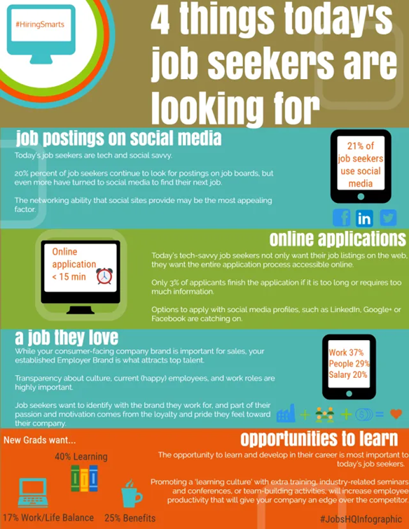  Source: https://www.jobshq.com/article/things-job-seekers-are-looking-for/  Task 2. Complete the following sentence with information from the infographic above.  - Two characteristics of today´s job applicants:  ______________________________________________  - Percentage of job seekers who use social media: __________  - Three application options job seekers use to apply for a job today:  _________________________________________________________  - Three characteristics of the companies job applicants look for today:  _________________________________________________________  - The most important aspect new graduates look for in a job today:  _________________________________________________________  Task 3. You just graduated from university and you are applying for a dream job. Write a cover letter. Use simple, coherent and well-written sentences.
Indicaciones o preguntas para auto regularse y evaluarse/ Instructions or questions for self-regulation and self- assessment | Review the following questions to self-regulate and self-assess:  Did I read the instructions carefully?  Did I check on the words that I didn’t understand?  Did I use a dictionary or asked a relative about the meaning of the words that I didn’t understand?  Did I read the instructions again when I didn’t understand what I had to do?

Con el trabajo autónomo voy a aprender a aprender/

With the self-study guide, I’m going to learn how to learn.

Reviso las acciones realizadas durante la construcción del trabajo. /
I check the actions carried out while completing the self-study guide

Marco una X encima de cada símbolo al responder las siguientes preguntas/
Mark with an X on the icon that answers the following questions.

¿Leí las indicaciones con detenimiento?
Did I read the instructions carefully?
¿Revisé las palabras que no conocía?
Did I check on the words that I didn’t understand?
¿Busqué en el diccionario o consulté con un familiar el significado de las palabras que no conocía?
Did I use the dictionary or asked a relative about the meaning of the words that I didn’t understand?
¿Me devolví a leer las indicaciones cuando no comprendí qué hacer?
Did I read the instructions again when I didn’t understand what I had to do?

Con el trabajo autónomo voy a aprender a aprender/

With the self-study guide, I’m going to learn how to learn.

Valoro lo realizado al terminar por completo el trabajo.
I self -assess what I did when I finish the study guide.

Marca una X encima de cada símbolo al responder las siguientes preguntas
Mark with an X on the icon that answers the following questions.

¿Leí mi trabajo para saber si es comprensible lo escrito o realizado?
I proofread what I did in my self-study guide.
¿Revisé mi trabajo para asegurarme si todo lo solicitado fue realizado?
I checked my self-study guide to make sure that everything is complete.
¿Me siento satisfecho con el trabajo que realicé?
I feel satisfied with the work I did.
Explico ¿Cuál fue la parte favorita del trabajo?
What was the favorite part of this work?

¿Qué puedo mejorar, la próxima vez que realice la guía de trabajo autónomo?
What can I improve the next time I work on the self study guide?

